11/8/2015
DELL
CBS iNFOSYS
FieldWorkMobility

1
HOW TO USE THE APPLICATION USER GUIDE
First of all we have to dowload this app (FieldWorkMobility) from play-Store and install.
HOME :-
This is the home screen of FieldWorkMobility application, Home consists of this several Buttons.
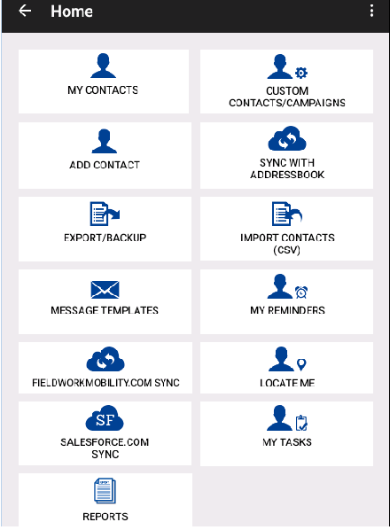
Fig 1.

- My Contacts
- Custom Contact/ Campaigns
- Add Contacts
- Sync with Address Book
- Export/Backup
- Import Contacts (CSV)
- Message Templates
- My Reminders
- FieldWorkMobility.com sync
- SalesForce.com sync
- Locate Me
- My Tasks
- Reports.

- My Contacts –
My contacts contains six button such as:
- CONTACTS
- MY CLIENTS
- MY LEADS
- MY PROSPECTS
- CREATE CUSTOM LISTS/CAMPAIGN
- MANAGE CUSTOM LISTS/CAMPAIGN

- CONTACTS –Contacts button is the main button where we can perform dialler modes or function by clicking on menu items such as:

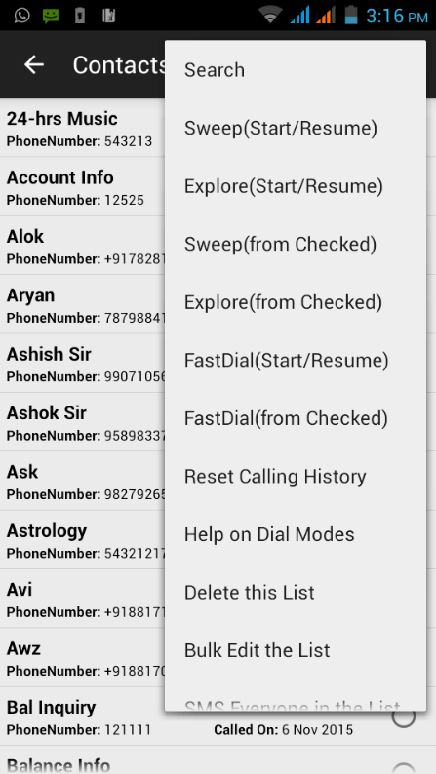
Fig 1.I. a

  - Search- Search menu is used to search contacts, with this different conditions like First name equals, start with and contains, Last Name equals, start with or contains Company name equal, start with or contains etc.
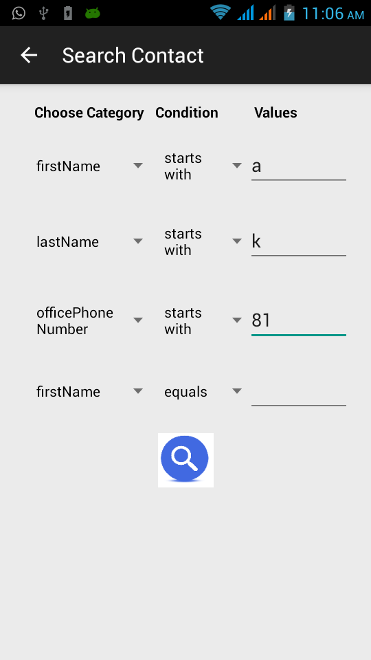
Fig 1. I. b
For ex. firstName start with “a” AND lastName start with “k” AND officePhoneNumber StartWith 81 after clicking on search icon, it will search those contact whose first name start with a , last name start with k and officePhoneNumber start with 81.

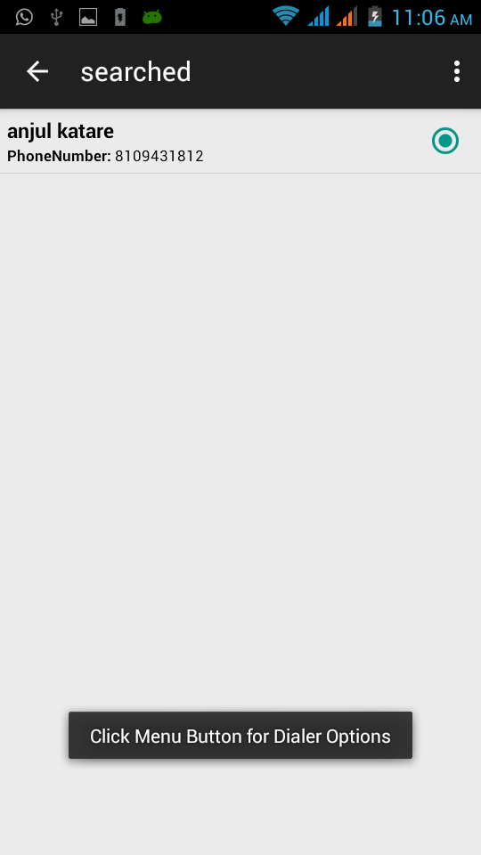
Fig 1. I. c
  - Sweep (Start/Resume) – We can perform dialler function, here in sweep (start/resume) function is used to quickly call different contacts in this lists. Start or continue after the last dialled contact. It will try dialing the contacts skipped by you earlier. This mode will not ask for any permission whether to dial next person.

  - Explore (Start/ Resume) - Start or continue after the last dialled contact with prospecting (i.e. review, update and schedule every contact after the call). It will try dialing the contacts skipped by you earlier.

  - Sweep (from checked) – Start Dialing every contact from the selected radio button. This mode will ask for your permission whether to dial next person.

  - Explore(from checked)- Start dialling every contact from the selected radio button with Prospecting (i.e. review, update and schedule every contact after the call )

  - Fast Dial (from checked) - Start Dialling every contact from the selected radio button. This mode will not ask for your permission whether to dial next person. However, you can press back key anytime to stop the dialler.

  - Fast dial (Start/ resume) - Start or continue after the last dialled contact. It will try dialling the contacts skipped by you earlier. This mode will not ask for your permission whether to dial next person. However, you can press back key anytime to stop the dialler.

  - Delete this list - This action will delete current list.

  - Bulk edit the list – you can bulk edit the current list using this feature.

  - SMS everyone in the list – you can SMS everyone in the current list.

  - Email everyone in the list – you can email everyone in the current list.

  - Reset calling History – This action resets any calling history associated with the Contacts. The dialler will start from the first contact of your list after the reset.

- ATTACH DOCUMENT/IMAGES –
Attach document menu is used to attach documents for selected contacts we can attach any kind of files except executable files (jar, exe, zip etc.) from the attach button and then click submit.
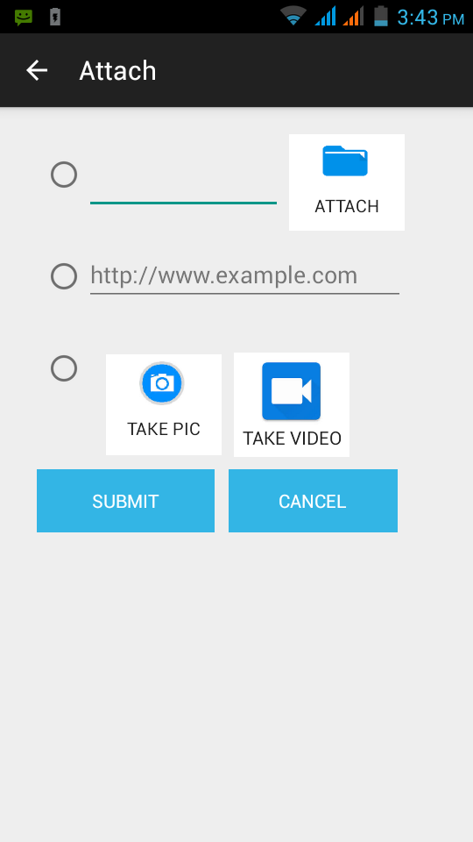
Fig 1. I. d
-PASTE URL –
If Agent choose 2nd radio button then he can paste URL (http://www.example.com) here and click SUBMINT then it will save for particular contact and can see saved document or can go with saved URL from View Document menu.

- TAKE PIC or RECORD VIDEO –
Agent can also click pictures or record videos and saved it into SD-CARD by clicking on TAKE PIC or TAKE VIDEO.

- VIEW DOCUMENTS- It shows the Document lists which we earlier have attached for the particular contacts.

- MY CLIENTS - If we select contact type is client then selected contacts go inside,
My clients tab.
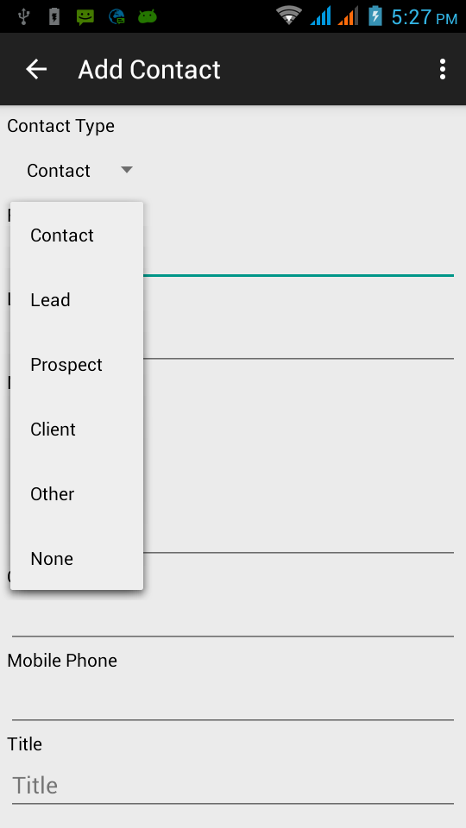
Fig 1. I. e
- My LEADS - If we select contact type is Leads then selected contacts become lead and stored into MY LEADS.

- MY PROSPECTS – If we select contact type is prospect then it will save into MY PROSPECT.

- CREATE CUSTOM LIST/CAMPAIGN – It gives facility to create custom list based on various condition.

The Agent can create a custom list which is the view of grand list.

For this just go to MY CONTACTS => CREATE CUSTOM LIST enter list name for ex. raj choose the field on which condition will apply for ex. firstName and then next choose the condition let’s say startwith then enter a value.

Now this will create a list with all the contacts whose name start with letter “m”.

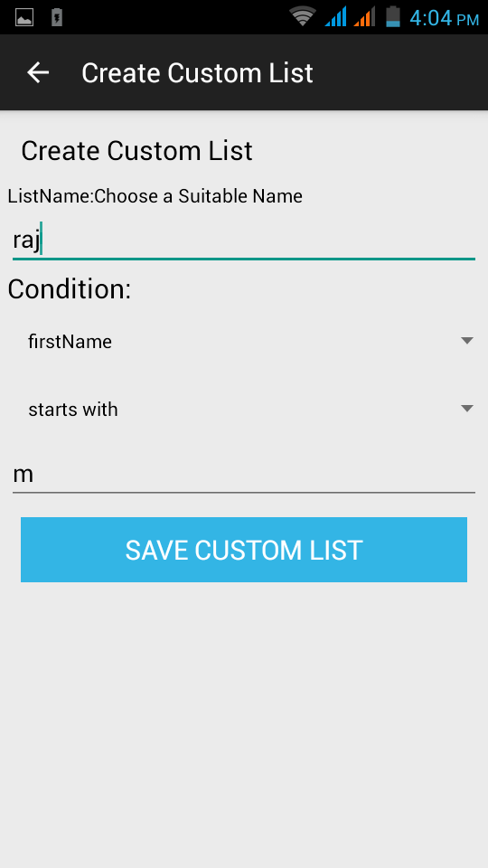
Fig 1. IV. a

- MANAGE CUSTOME LIST/CAMPAIGN – We can Edit or delete created custom lists by simply clicking on edit or delete button.

- CUSTOME CONTACS - It shows earlier created custom lists.
Ex. We have earlier created custom list name raj which starts with letter “m”.

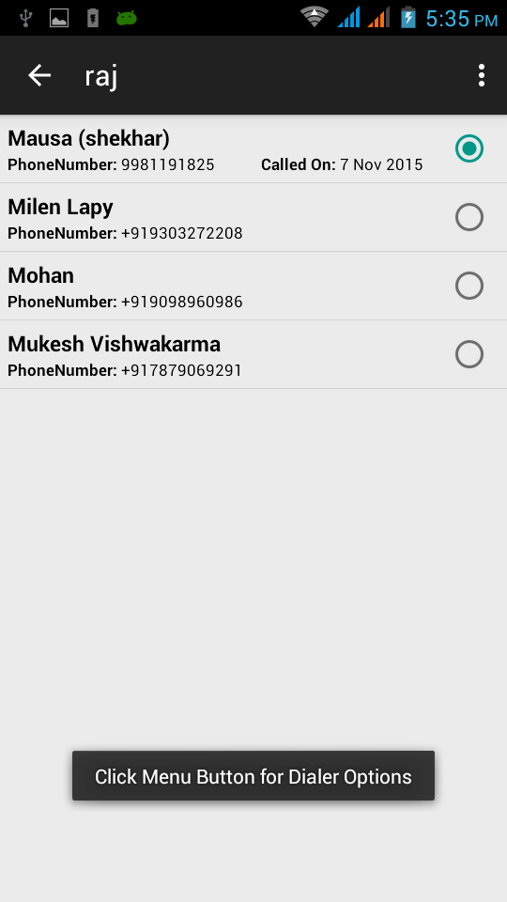
Fig 2. a
Here we can use dialler modes for this Fig. specific contacts.
- ADD CONTACT - Add contact is simply used for creating new Contacts.
- SYNC WITH ADDRESSBOOK- It is used for importing and exporting Contacts from device and to device.
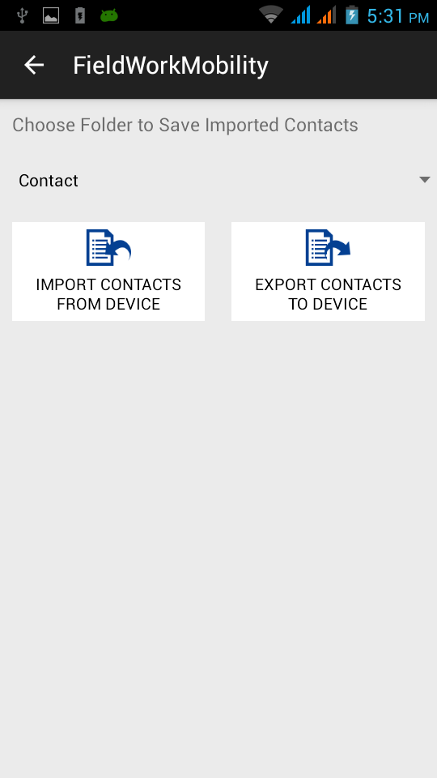
Fig 4. a
- IMPORT CONTACTS FROM DEVICE - It will import all contacts from device.
- EXPORT CONTACTS TO DEVICE – This is used to export all contacts from Fieldwork Mobility app into device.

- EXPORT/BACKUP – It is used to export contact or backup contacts as CSV format on your EXTERNAL STORAGE (/SD CARD).

For this click EXPORT/BACKUP button from Main and then click on EXPORT CONTACTS AS CSV ON YOUR EXTERNAL STORAGE.

- IMPORT CONTACTS (CSV) - It is used to select contacts (CSV file) or import CSV file from external storage (SD CARD).
- MESSAGE TEMPLATES - It consists of two templates, Message Templates and email Templates. Go to MESSAGE TEMPLATES from the home screen.
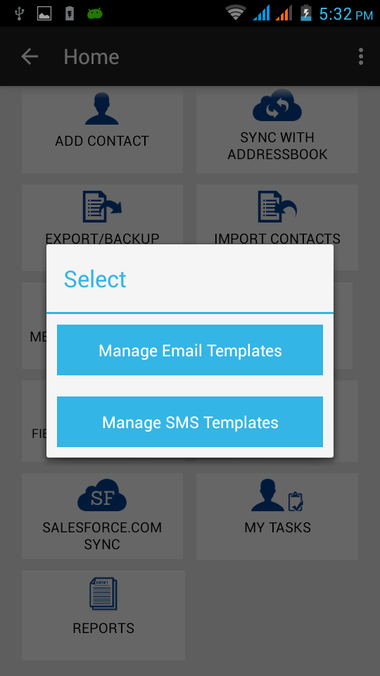
Fig 7. a
- Manage Email Templates – We can create Email templates by clicking on create New EMAIL TEMPLATE.

Steps:-
Click CREATE NEW EMAIL TEMPLATE
- Enter name of the template --- for example- thanks
- Then Choose where you want insert templates
- Then enter subject into subject area.
- Then enter your desire text into body section.
- Then click on SAVE TEMPLATE.
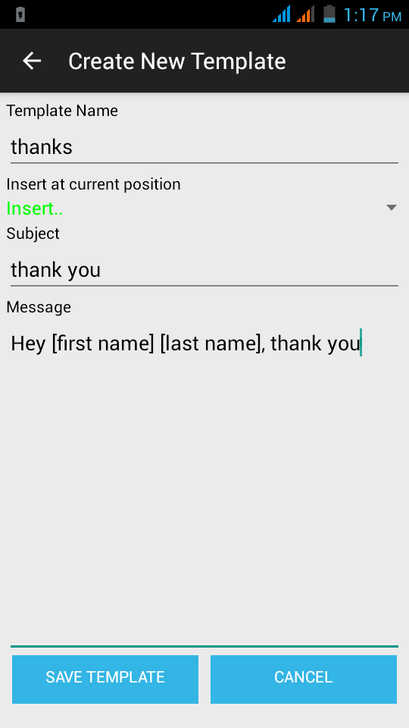
Fig 7. b

Now let’s send email using this templates
Steps-:
Click on CONTACTS from main screen and then click MY CONTACTS and then click any contact from this list whom you want to send email and now go to email from the menu then you can see the template here, If there are multiple templates you can choose from them and add some messages if you want and then click on send.
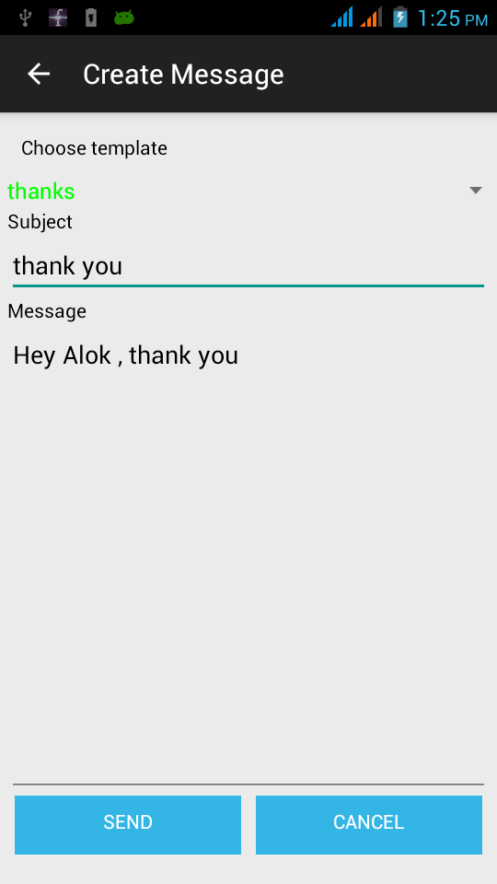
Fig 7. c

We can also manage templates such as delete or edit after click on created Templates.

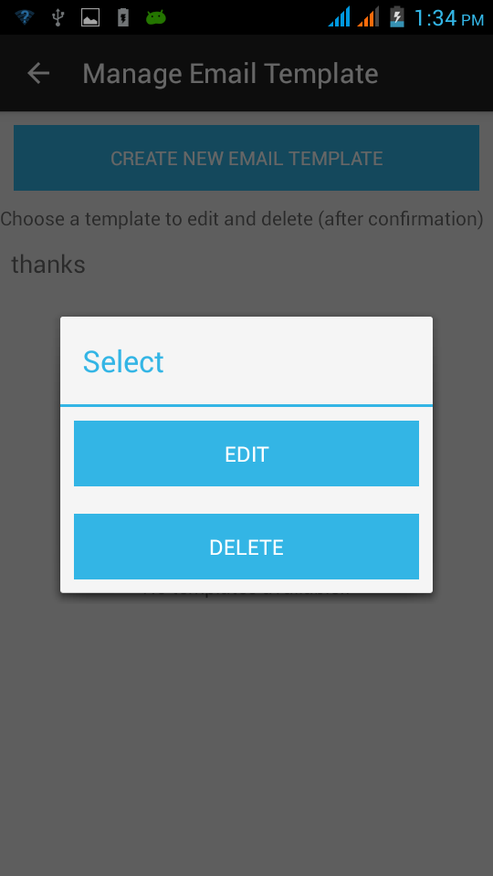
Fig 7. d
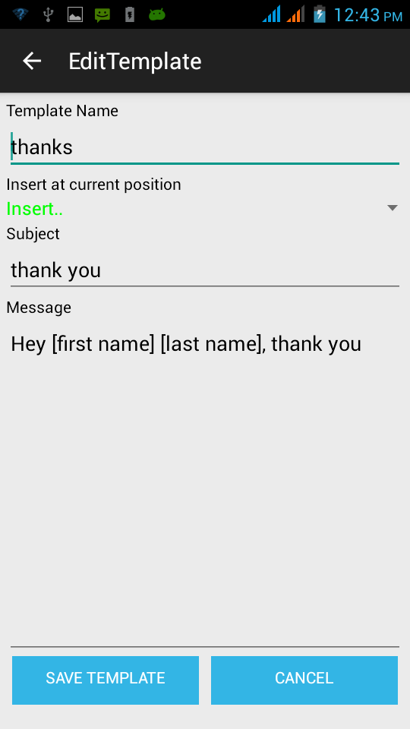
Fig 7. e
- Manage SMS Templates – We can create SMS templates by clicking on create New SMS Templates. And can manage SMS TEMPLATES by clicking on templates.

- MY REMINDERS – For Creating Reminders Go to CONTACTS then MY CONTACTS then click any contact where you want to add reminder.
Select reminder checkbox and set calendar.

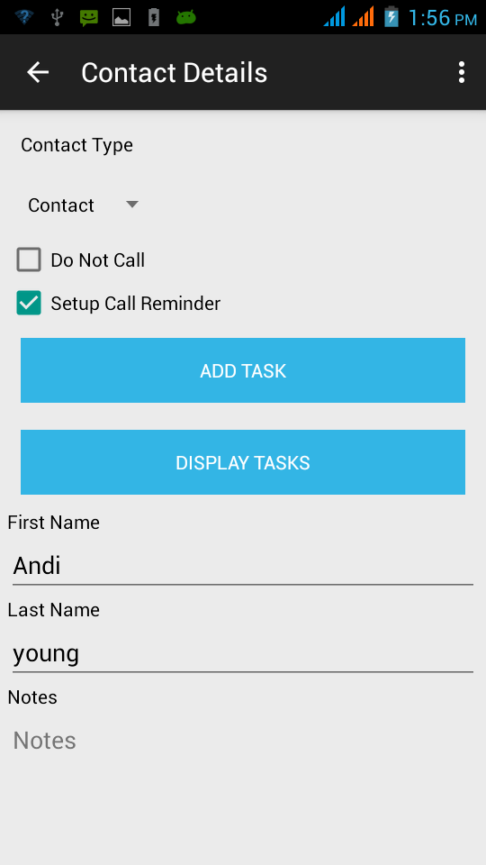
Fig 8. a
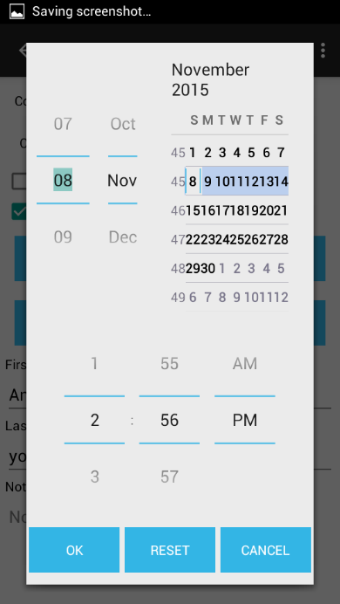
Fig 8. b

- FIELDWORKMOBILITY.COM SYNC –Now let’s see how the Agent will import the CSV data which has been uploaded by the business owner from the dash board.
For this he needs to click on FIELDWORKMOBILITY.COM SYNC enter the user name of the business owner of the sales manager the verification code then click on LOGIN TO FIELDWORKMOBILITY.COM and then SYNC DATA WITH FIELDWORKMOBILITY.COM you need to connected to the internet for this data.
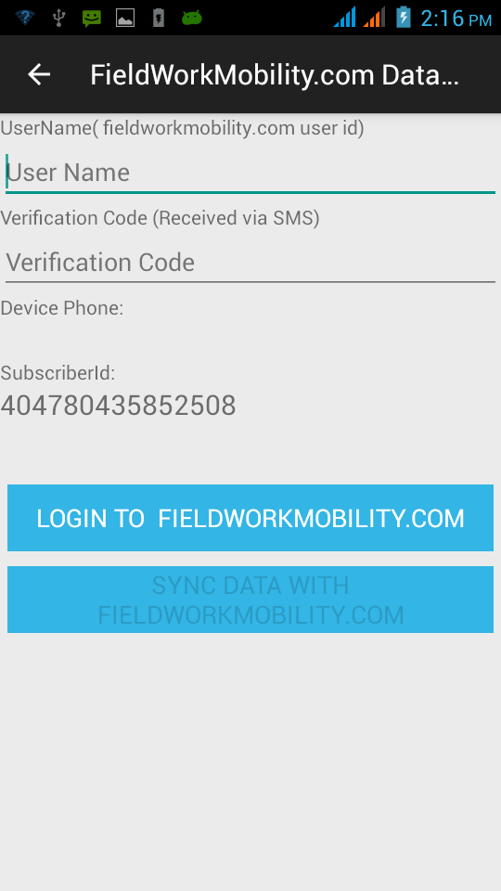
Fig 9. a
- LOCATE ME – Locate me is used to locate current location and REPORT ME button is used to report his location or address.

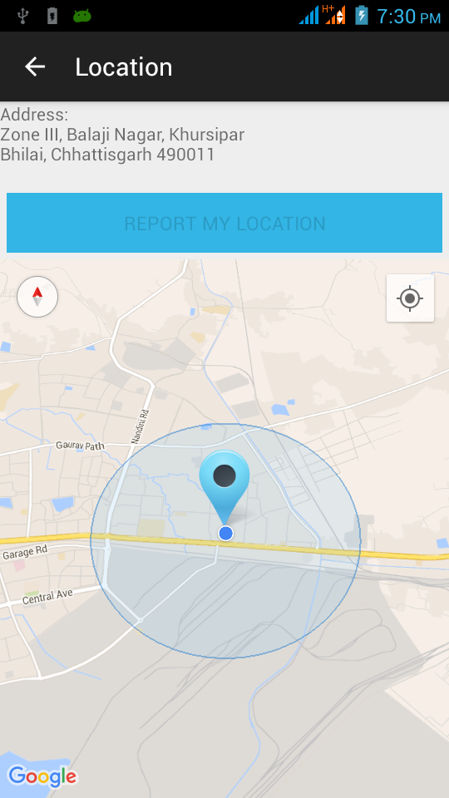
Fig 10. a

- SALESFORCE.COM SYNC –

The agent can also uses SALESFORCE.COM account to import contacts for this just click on SALESFORCE.COM SYNC from the home page just need to enter your user name and Password and then you can import all the context right into the app.
.
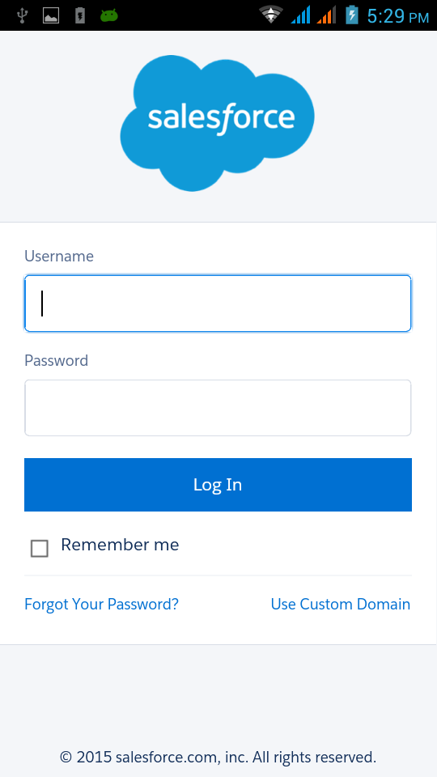
Fig 11. a
- MY TASKS – Agent can add task for each contacts for this go to contacts and then click any contacts from the list and then go to Add Task then the task screen will open then enter Task title and enter description then priority and status then say ADD TASK. The task will be added for this particular contact.
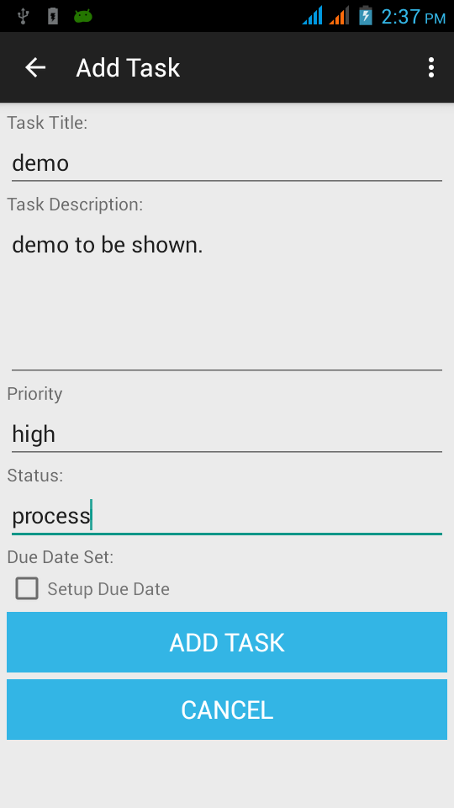
Fig: 12. a

